**YEAR 12 PHYSICS, UNIT 4**

#### Power Transmission, Wave-Particle Duality and Quantum Test

#### 

**NAME: ____________________________________**

**TOTAL MARKS: /61**

**TIME ALLOWED FOR THIS PAPER**

Working time for paper: 55 minutes

**INSTRUCTIONS TO CANDIDATES**

Answer all questions.

**Sufficient working** should be shown on all calculation, with a complete, logical, clear sequence of reasoning showing how the final answer was arrived at. Correct answers which do not show full working will not necessarily be awarded full marks.

Give final answers to three significant figures, using scientific notation if needed, and include appropriate units where applicable.

When estimating numerical answers or reading information from a chart or graph, give final answers to a maximum of two significant figures and include appropriate units where applicable. Clearly state any assumptions or estimations which are made.

Question 1 [5 Marks]

Rayleigh-Jeans Law states that the intensity of radiation emitted from a black body is directly proportional to the temperature $(I∝T)$ and inversely proportional to wavelength raised to the fourth power $(I∝\frac{1}{λ^{4}})$. This led to an early problem known as the Ultraviolet Catastrophe, wherein the classical physics prediction (Rayleigh-Jeans Law) did not agree with experiment and observation.

1. State the details of this disagreement (i.e., what did the theory predict and what did the evidence show?): (3)

_____________________________________________________________________________

_____________________________________________________________________________

_____________________________________________________________________________

_____________________________________________________________________________

_____________________________________________________________________________

_____________________________________________________________________________

1. Max Planck was able to resolve the discrepancy between theory and experiment. State the assumption(s) he made that allowed him to do this, and how this affected our understanding of electromagnetic radiation: (2)

_____________________________________________________________________________

_____________________________________________________________________________

_____________________________________________________________________________

_____________________________________________________________________________

Question 2 [3 marks]

A radio transmitter uses a metallic aerial to broadcast a signal. It does this by oscillating electrons in the aerial, producing 2.05 x 1030 photons per second. The radio transmission has a wavelength of 680 m. Determine the power of the radio transmitter (to the nearest hundred Watts).

**Question 3 [4 marks]**

The diagram below shows part of the circuit for a burglar alarm.

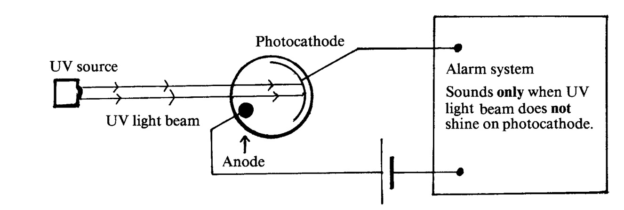

The alarm system is arranged in such a way that, when ultra-violet (UV) light shines on the photocathode, the alarm does **not** sound but when the UV light beam is broken the alarm will start to sound.

a) Which of the statements (A-D) below is the best explanation of the effect of shining UV light on the photocathode? Circle one statement. (2)

A The UV light photons eject electrons from the photocathode causing an electric current to flow in the circuit.

B The UV light photons eject positive charges from the photocathode causing an electric current to flow in the circuit.

C The UV light prevents electrons from being ejected from the photocathode, hence the alarm sounds only when the beam is broken.

D The UV light deflects electrons which normally flow from the photocathode to the anode.

The ultra-violet light source is now replaced by a source of red light.

b) Which of the statements (A-D) below best describes the result of this replacement? Circle one statement. (2)

A The alarm will definitely operate as normal.

B The alarm will now ring whether or not the light beam is broken.

C The alarm will now ring when the light beam is shining but will stop when the beam is broken.

D Whether or not the alarm will operate normally depends on the value of the work function of the photocathode material.

**Question 4 [3 Marks]**

The electromagnetic spectrum of the star Betelgeuse is shown below. Like most stars, the spectrum is very close to that of an ideal black body radiator. The range of wavelength of visible light is shown by the vertical column.

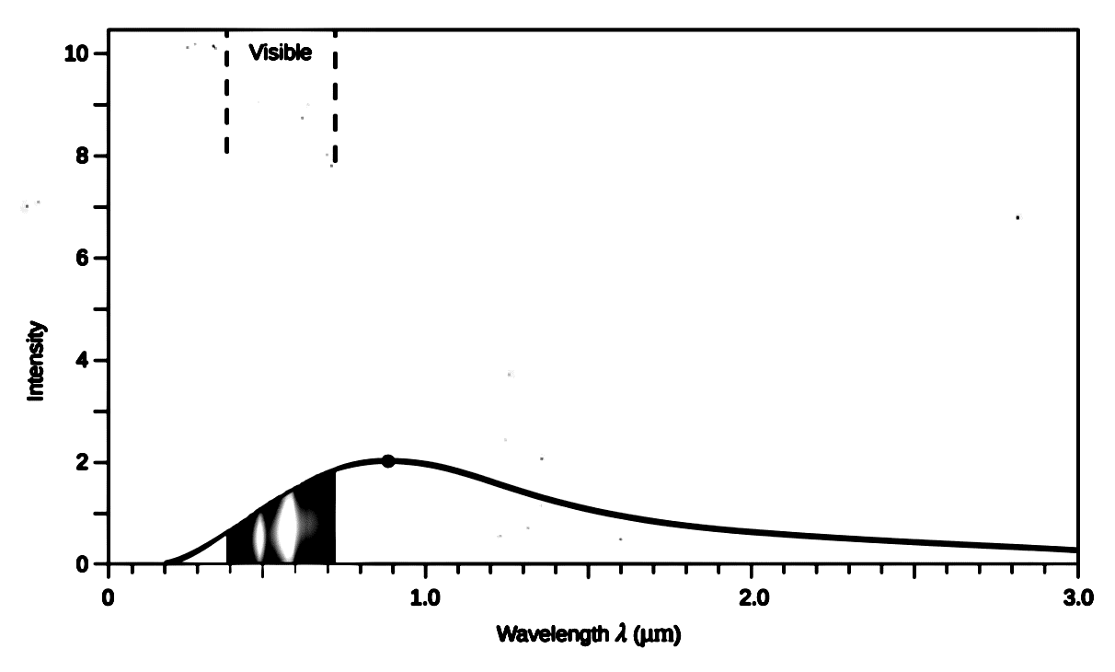

**Emission spectrum of Betelgeuse**

1. What (visible) colour would you expect Betelgeuse to appear? __________ (1)
2. Betelgeuse’ neighbouring star Bellatrix has a much hotter surface temperature. Draw a curve on the graph above to show a possible spectrum of Bellatrix. (2)

Question 5 [4 Marks]

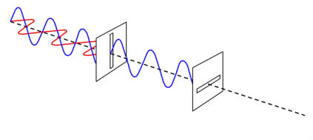Describe the phenomenon of polarization and explain briefly, with reference to the diagram, how it supports the wave model for light.

______________________________________________

______________________________________________

______________________________________________

________________________________________________________________________________

________________________________________________________________________________

________________________________________________________________________________

________________________________________________________________________________

Question 6 [9 marks]

Pictured below is an example of a spectrum graph, above which we see both an absorption and emission spectrum for the same element. Measurements for this graph were made using astronomical spectroscopy observations of a nearby stellar cluster.

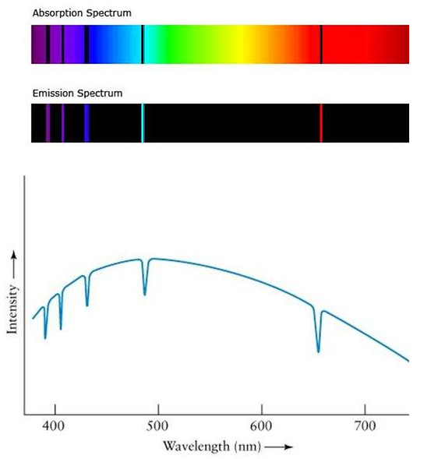

a) Does the spectrum graph represent an

absorption or emission spectrum? (1)

_______________________________________

b) An astrophysicist could identify the element

through analysis of the graph. Explain how

this is possible. (4)

_______________________________________

_______________________________________

_______________________________________

_______________________________________

_______________________________________

___________________________________________________________________________

___________________________________________________________________________

___________________________________________________________________________

c) Two physics students disagree on what the spectrum graph represents. The first asserts that the

graph reveals the elemental composition of a nearby star in the stellar cluster. The second argues

that the graph shows the elemental composition of a gaseous nebula or planetary atmosphere

located between the stellar cluster and Earth. Which student is most likely to be correct? (4)

________________________________________________________________________________

________________________________________________________________________________

________________________________________________________________________________

________________________________________________________________________________

________________________________________________________________________________

________________________________________________________________________________

Question 7 [4 Marks]

An aurora is the appearance of coloured “curtains” of light in the sky near the Earth’s poles. The light comes from the atoms high in the atmosphere which have been “excited” by streams of charged particles entering the atmosphere from the sun or from the Earth’s radiation belts. The green colour in an aurora is due to the emission from excited oxygen atoms and has a wavelength of 565 nm.

Part of the energy level diagram for oxygen is shown on the right:

Which electron transition (A, B or C) is responsible for the green light? (Show all calculations and reasoning).

A

C

B

E3 = -1 eV

E2 = -3.2 eV

E1 = -5.2 eV

Question 8 [5 Marks]

The diagram shows some energy levels, in eV, of an atom.

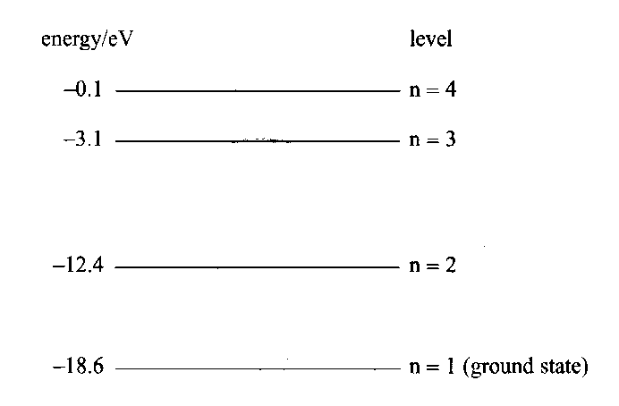

a) How many emission lines are possible in total between these energy levels? (1)

b) What is the ionisation energy, in eV, for an electron in the ground state? (1)

In its ground state, the atom is bombarded by an incident *electron* with 2.1 x 10‑18 J of energy.

c) Calculate the possible energies, in eV, with which this incident electron could be scattered from the atom after the collision. (3)

**Question 9 [8 marks]**

In early experiments to investigate the photoelectric effect, a beam of light of a single frequency was directed at a clean surface of potassium metal. The maximum kinetic energy of electrons which were ejected from the metal was measured.

When the experiment was repeated with different frequencies of light the maximum kinetic energy of electrons depended on the frequency of the light as shown below.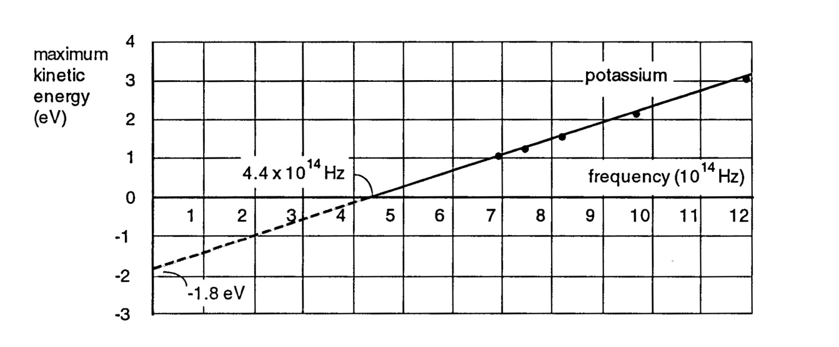

a) What is the minimum energy of a light photon that can eject an electron from potassium metal? (Answer in units of eV) (1)

The graph above shows that electrons ejected by light of frequency 6.0 x 1014 Hz have a maximum kinetic energy of 0.7 eV. The maximum kinetic energy of electrons ejected by light of frequency

1.2 x 1015 Hz is 3.2 eV

b) Explain why the maximum kinetic energy of electrons ejected by light of a higher frequency is greater than the maximum kinetic energy of electrons ejected by light of a lower frequency. (2)

___________________________________________________________________________

___________________________________________________________________________

___________________________________________________________________________

___________________________________________________________________________

___________________________________________________________________________

c) Light of frequency 9 x 1014 Hz is shone on the sample and the potential bias is reversed. Calculate the minimum reverse bias needed to stop the photo current (i.e., the stopping voltage). (3)

The minimum photon energy required to eject electrons from copper is approximately double the value for potassium.

d) Which of the graphs below would best describe the results if the experiment were repeated with copper instead of potassium? Explain your choice, commenting on the slope of the lines for potassium and copper and the points where the lines cross the frequency axis. (2)

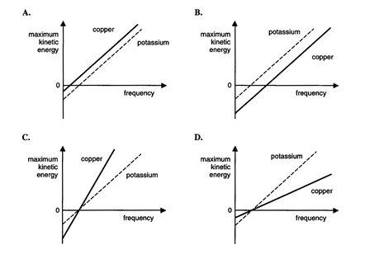

Answer: _______

Explanation: _____________________________________________________________________

_______________________________________________________________________________

_______________________________________________________________________________

Question 10 [5 Marks]

A 650 nm laser is shone through a diffraction grating.

1. Calculate the momentum of a photon fired from this laser. (1)
2. Determine the speed at which an electron would need to move in order to achieve the same de Broglie wavelength as the photon. (2)
3. The four statements below relate to de Broglie’s postulate. One of them is incorrect. Identify this statement and re-write it correctly. (2)
   1. It suggested a reason for Bohr’s quantisation of electron energy levels in atoms.
   2. It suggested that electrons in atoms can be considered as standing waves
   3. It explained why electrons have momentum
   4. The location of particles in motion can be considered ‘spread out’ over a distance rather than located at a particular point.

Question 11 [11 Marks]

A small town is supplied with electricity from a smal hydroelectric generation plant about 20 km from

the town. Electricity is transmitted through a high-voltage transmission lines. The voltage supplied at

the generator end is 50 000 volts (RMS). The RMS current in the lines is 15 amperes. At the edge of

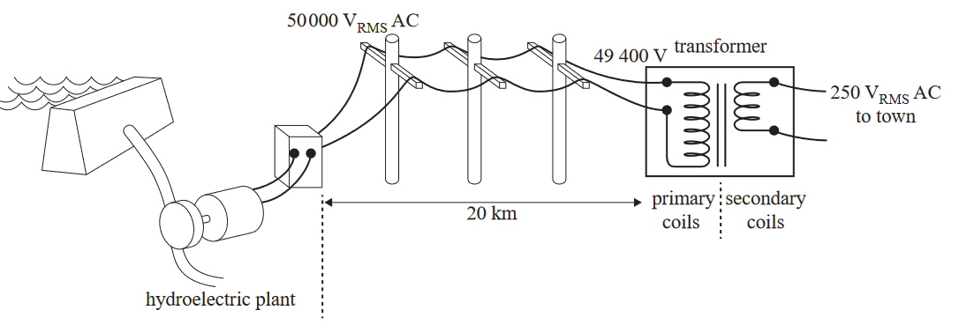town a substation transformer converts this to 250 V. This is shown in the figure below.

Substation transformer

1. Calcuate the power supplied by the plant. (1)
2. The voltage that is delivered to the substation transformer is 49 400 V. Calculate the total resistance of the transmission lines. (2)
3. The primary coil in the substation transformer has 9880 turns. Calculate the number of turns in the secondary coil (assume no power loss). (2)
4. The high voltage transmission lines are held by towers at a height of 12 m. Calculate the mean magnitude of the magnetic field that would be experienced at ground level due to the 15 A overhead current. (2)

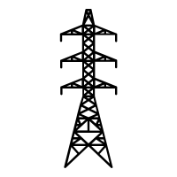

12 m

1. Some townspeople are concerned about the high voltage towers and their associated magnetic fields. They suggest that the power could be more safely supplied at a lower voltage. Clearly explain why this would result in large losses of energy. (3)

_____________________________________________________________________________________________________________________________________________________________________________________________________________________________________________________________________________________________________________________________________________________________________________________________________________________________________________________________________________________________________________________________________________

1. Calcuate the peak voltage of the town supply. (1)

**END OF TOPIC TEST**